# Dữ liệu Top các trường lĩnh vực kinh tế 2008-2019:

* Lĩnh vực kinh tế lấy theo các ngành:
  + Business: 361
  + Economics: 930
  + Management: 153

(chú ý số lượng các bài ở các ngành này có thể overlap)

* Danh sách các trường được rút ra theo bài viết, chỉ lấy các cơ quan cấp 1, sản lượng được tính cộng các cơ quan con cho cơ quan cấp 1
  + Danh sách đầy đủ 178 cơ quan có bài ở lĩnh vực kinh tế (3 ngành trên) xem file excel
  + Danh sách top bao gồm 18 cơ quan theo thứ tự số lượng bài giảm dần. Danh sách 18 cơ quan này chiếm 70% tổng sản lượng

(chú ý số lượng bài các cơ quan này có thể overlap do có hợp tác)

* Dữ liệu đủ trong tệp data.xlsx

|  |  |  |  |  |
| --- | --- | --- | --- | --- |
| **#** | **Affiliation** | **Articles** | **Authors** | **%** |
| 1 | National Economics University Hanoi | 167 | 108 | 13% |
| 2 | University of Economics Ho Chi Minh City | 124 | 55 | 23% |
| 3 | Vietnam National University Hanoi | 121 | 81 | 32% |
| 4 | Ho Chi Minh City Open University | 72 | 47 | 37% |
| 5 | Vietnam National University Ho Chi Minh City | 60 | 37 | 42% |
| 6 | Foreign Trade University | 57 | 47 | 47% |
| 7 | Thuongmai University | 40 | 34 | 50% |
| 8 | Vietnam Academy of Social Sciences | 37 | 40 | 52% |
| 9 | RMIT University Vietnam | 35 | 15 | 55% |
| 10 | Ton Duc Thang University | 26 | 17 | 57% |
| 11 | Banking University of Ho Chi Minh City | 25 | 30 | 59% |
| 12 | Nha Trang University | 24 | 14 | 61% |
| 13 | Hanoi Medical University | 24 | 13 | 63% |
| 14 | Banking Academy Hanoi | 21 | 19 | 64% |
| 15 | Academy of Finance (Vietnam) | 20 | 9 | 66% |
| 16 | Ministry of Planning and Investment | 16 | 11 | 67% |
| 17 | Mekong Development Research Institute | 15 | 7 | 68% |
| 18 | Hue University | 14 | 11 | 70% |

## Số bài các trường theo năm

|  |  |  |  |
| --- | --- | --- | --- |
| **Year** | **Affiliation** | **Author** | **Article** |
| 2008 | Vietnam National University Hanoi | 1 | 1 |
| 2009 | National Economics University Hanoi | 6 | 10 |
| 2009 | Foreign Trade University | 1 | 1 |
| 2010 | National Economics University Hanoi | 3 | 3 |
| 2010 | Vietnam National University Ho Chi Minh City | 1 | 1 |
| 2010 | Foreign Trade University | 1 | 1 |
| 2010 | Thuongmai University | 1 | 1 |
| 2011 | National Economics University Hanoi | 3 | 3 |
| 2011 | Vietnam National University Hanoi | 1 | 1 |
| 2011 | University of Economics Ho Chi Minh City | 1 | 4 |
| 2011 | Vietnam National University Ho Chi Minh City | 2 | 2 |
| 2011 | Thuongmai University | 1 | 1 |
| 2012 | National Economics University Hanoi | 2 | 2 |
| 2012 | University of Economics Ho Chi Minh City | 1 | 1 |
| 2012 | Foreign Trade University | 1 | 1 |
| 2013 | National Economics University Hanoi | 4 | 7 |
| 2013 | Vietnam National University Hanoi | 1 | 1 |
| 2013 | University of Economics Ho Chi Minh City | 2 | 2 |
| 2013 | Foreign Trade University | 1 | 1 |
| 2013 | Thuongmai University | 1 | 1 |
| 2014 | National Economics University Hanoi | 1 | 5 |
| 2014 | Vietnam National University Hanoi | 3 | 2 |
| 2014 | University of Economics Ho Chi Minh City | 1 | 1 |
| 2014 | Foreign Trade University | 2 | 2 |
| 2014 | Ho Chi Minh City Open University | 1 | 1 |
| 2015 | National Economics University Hanoi | 5 | 6 |
| 2015 | University of Economics Ho Chi Minh City | 5 | 6 |
| 2015 | Foreign Trade University | 1 | 1 |
| 2016 | National Economics University Hanoi | 6 | 3 |
| 2016 | Vietnam National University Hanoi | 3 | 3 |
| 2016 | University of Economics Ho Chi Minh City | 5 | 13 |
| 2016 | Foreign Trade University | 4 | 4 |
| 2017 | National Economics University Hanoi | 9 | 12 |
| 2017 | Vietnam National University Hanoi | 2 | 2 |
| 2017 | University of Economics Ho Chi Minh City | 6 | 7 |
| 2017 | Vietnam National University Ho Chi Minh City | 2 | 1 |
| 2017 | Foreign Trade University | 4 | 3 |
| 2017 | Thuongmai University | 1 | 2 |
| 2017 | Ho Chi Minh City Open University | 6 | 8 |
| 2018 | National Economics University Hanoi | 12 | 12 |
| 2018 | University of Economics Ho Chi Minh City | 9 | 15 |
| 2018 | Thuongmai University | 2 | 2 |
| 2019 | National Economics University Hanoi | 38 | 30 |
| 2019 | Vietnam National University Hanoi | 4 | 3 |
| 2019 | University of Economics Ho Chi Minh City | 6 | 6 |
| 2019 | Foreign Trade University | 11 | 9 |
| 2019 | Thuongmai University | 6 | 4 |
| 2019 | Ho Chi Minh City Open University | 9 | 7 |

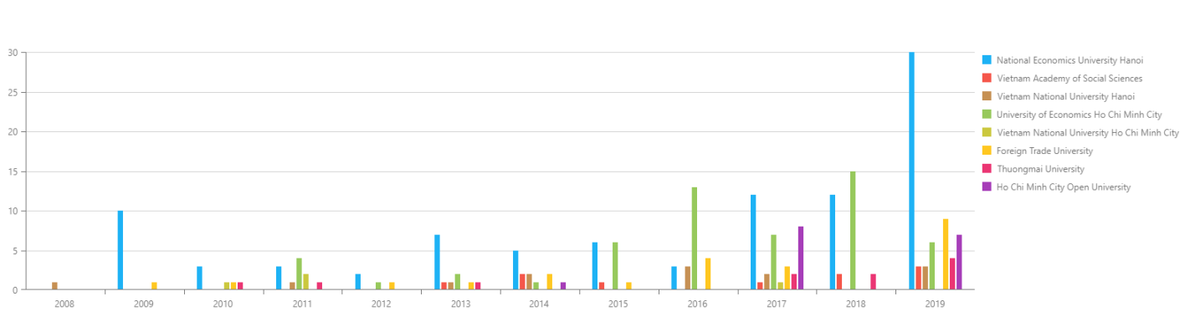

Fig 1. Tổng số bài của 8 trường top đầu

* Năng xuất các trường không ổn định???
* Có những trường rơi vào top như ĐH mở Tp. HCM nhưng chỉ có 5 năm trong tổng số 12 năm là có bài

## Tỉ lệ nam / nữ theo độ tuổi

|  |  |
| --- | --- |
| TỔNG SỐ BÀI NAM / NỮ | |
| E:\bayesvl\packages\bayesvl\LectureNotes\6.1.SSHPA(top affiliation)\Graphs\fig2.1.png  (NEU) National Economics University Hanoi | E:\bayesvl\packages\bayesvl\LectureNotes\6.1.SSHPA(top affiliation)\Graphs\fig2.2.png  (UOEH) University of Economics Ho Chi Minh City |
| E:\bayesvl\packages\bayesvl\LectureNotes\6.1.SSHPA(top affiliation)\Graphs\fig2.3.png  (VNUH) Vietnam National University Hanoi | E:\bayesvl\packages\bayesvl\LectureNotes\6.1.SSHPA(top affiliation)\Graphs\fig2.4.png  (HCMOpenUni) Ho Chi Minh City Open University |
| E:\bayesvl\packages\bayesvl\LectureNotes\6.1.SSHPA(top affiliation)\Graphs\fig2.5.png  (VNUHCM) Vietnam National University Ho Chi Minh City | E:\bayesvl\packages\bayesvl\LectureNotes\6.1.SSHPA(top affiliation)\Graphs\fig2.6.png  (FTU) Foreign Trade University |
| E:\bayesvl\packages\bayesvl\LectureNotes\6.1.SSHPA(top affiliation)\Graphs\fig2.7.png  (TMU) Thuongmai University | E:\bayesvl\packages\bayesvl\LectureNotes\6.1.SSHPA(top affiliation)\Graphs\fig2.8.png  (VASS) Vietnam Academy of Social Sciences |

## Số tác giả mới

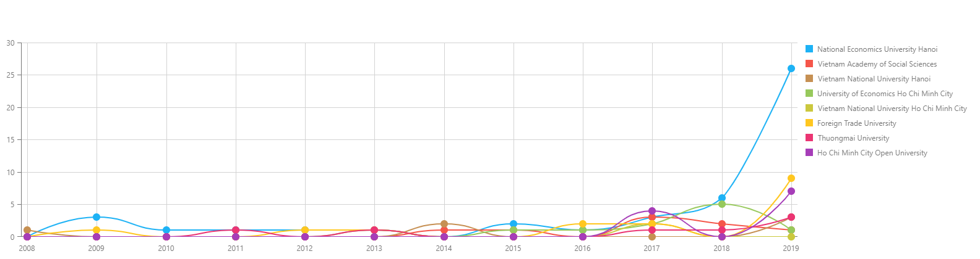

## Số tác lead

## JIF